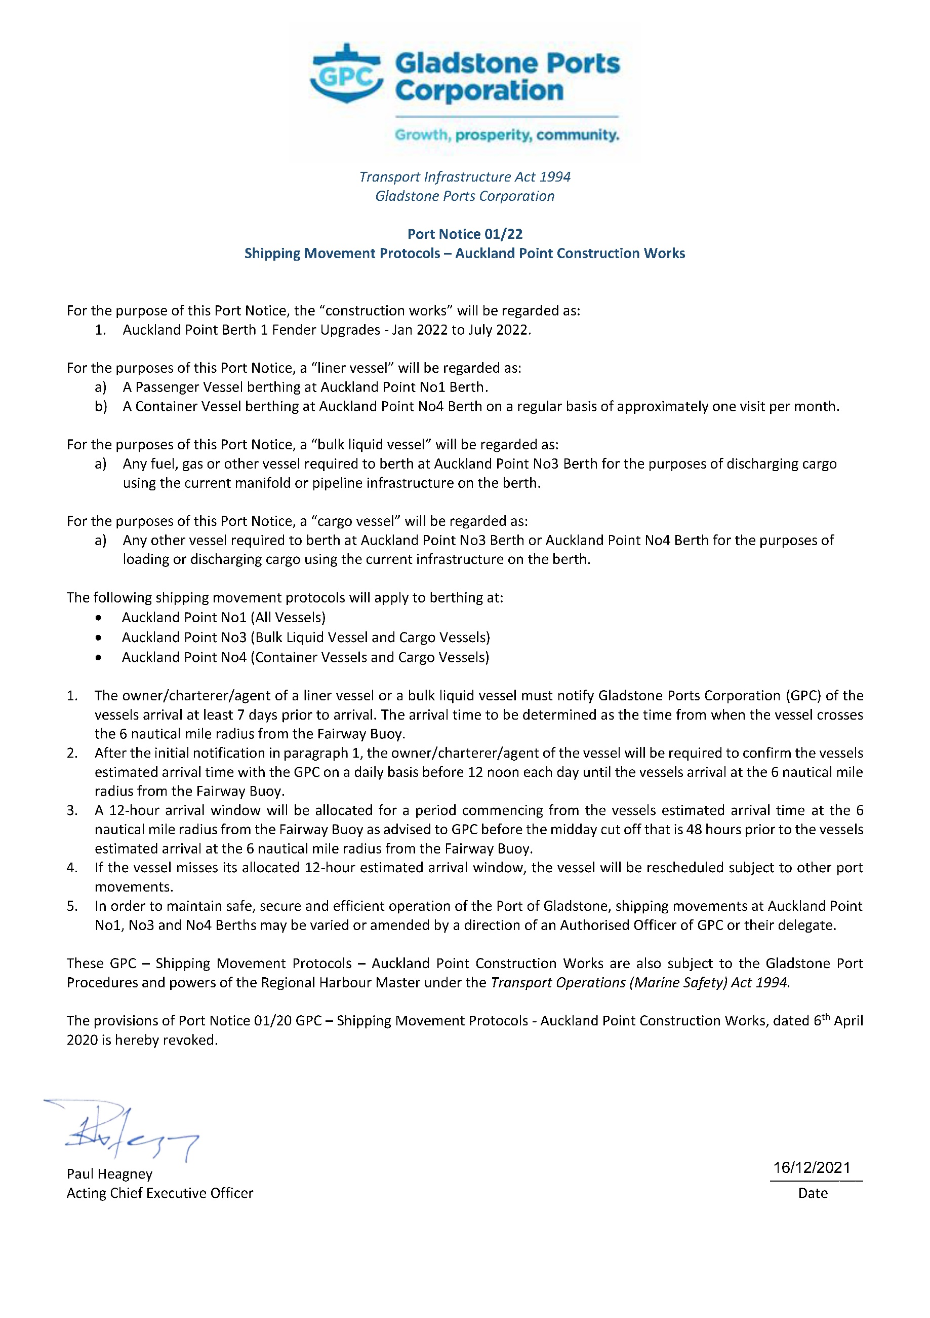
Transport Infrastructure Act 1994
Gladstone Ports Corporation

Port Notice 01/22
Shipping Movement Protocols – Auckland Point Construction Works

For the purpose of this Port Notice, the “construction works” will be regarded as:
- Auckland Point Berth 1 Fender Upgrades - Jan 2022 to July 2022.

For the purposes of this Port Notice, a “liner vessel” will be regarded as:
- A Passenger Vessel berthing at Auckland Point No1 Berth.
- A Container Vessel berthing at Auckland Point No4 Berth on a regular basis of approximately one visit per month.

For the purposes of this Port Notice, a “bulk liquid vessel” will be regarded as:
- Any fuel, gas or other vessel required to berth at Auckland Point No3 Berth for the purposes of discharging cargo using the current manifold or pipeline infrastructure on the berth.

For the purposes of this Port Notice, a “cargo vessel” will be regarded as:
- Any other vessel required to berth at Auckland Point No3 Berth or Auckland Point No4 Berth for the purposes of loading or discharging cargo using the current infrastructure on the berth.

The following shipping movement protocols will apply to berthing at:
- Auckland Point No1 (All Vessels)
- Auckland Point No3 (Bulk Liquid Vessel and Cargo Vessels)
- Auckland Point No4 (Container Vessels and Cargo Vessels)

- The owner/charterer/agent of a liner vessel or a bulk liquid vessel must notify Gladstone Ports Corporation (GPC) of the vessels arrival at least 7 days prior to arrival. The arrival time to be determined as the time from when the vessel crosses the 6 nautical mile radius from the Fairway Buoy.
- After the initial notification in paragraph 1, the owner/charterer/agent of the vessel will be required to confirm the vessels estimated arrival time with the GPC on a daily basis before 12 noon each day until the vessels arrival at the 6 nautical mile radius from the Fairway Buoy.
- A 12-hour arrival window will be allocated for a period commencing from the vessels estimated arrival time at the 6 nautical mile radius from the Fairway Buoy as advised to GPC before the midday cut off that is 48 hours prior to the vessels estimated arrival at the 6 nautical mile radius from the Fairway Buoy.
- If the vessel misses its allocated 12-hour estimated arrival window, the vessel will be rescheduled subject to other port movements.
- In order to maintain safe, secure and efficient operation of the Port of Gladstone, shipping movements at Auckland Point No1, No3 and No4 Berths may be varied or amended by a direction of an Authorised Officer of GPC or their delegate.

These GPC – Shipping Movement Protocols – Auckland Point Construction Works are also subject to the Gladstone Port Procedures and powers of the Regional Harbour Master under the Transport Operations (Marine Safety) Act 1994.

The provisions of Port Notice 01/20 GPC – Shipping Movement Protocols - Auckland Point Construction Works, dated 6th April 2020 is hereby revoked.

Paul Heagney ____________
Acting Chief Executive Officer Date

