Date of submission:
Click or tap to enter a date.
Guidance for Completing

Information provided
To help us support you as quickly and effectively as possible, please complete all sections of the form. The more information you provide, the better we can understand your needs and respond with appropriate recommendations.

Completing the form
Guidance notes are included throughout to assist you in completing each section. You can type directly over these notes with your responses.
If you are unable to complete a section, please indicate why and, if possible, when the information will be available.
If anything is unclear, please do not hesitate to contact us directly for assistance.
Estimated time to complete: 10–15 minutes

Process
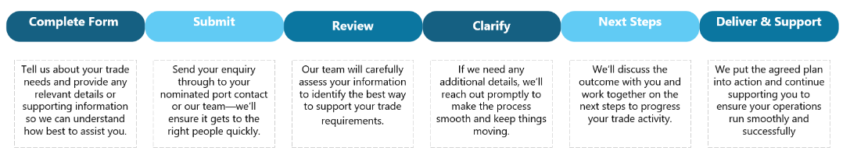

Next Steps
Once submitted, GPC will review your enquiry and respond with next steps, which may include requests for further information, technical review, or commercial discussions.

For assistance completing this form, please contact:
Email: property@gpcl.com.au
Phone:4976 1333

- Customer/ Company Details
Information Required | Details
Legal entity name of Customer  If Customer is a company – specify the full company name | Click or tap here to enter text.
Customer’s Australian Company Number (ACN) or Australian Business Number (ABN)  *If Customer does not have ACN and/or ABN, please provide applicable and equivalent details | Click or tap here to enter text.
Address (Street, City, State, Postcode) | Click or tap here to enter text.
Contact name | Click or tap here to enter text.
Contact email | Click or tap here to enter text.
Contact telephone | Click or tap here to enter text.
Stage of enquiry | [Stage of Enquiry].
Please describe what is critical to you in relation to this enquiry so we focus on the items that matter to you | [Please detail your top priorities, your definition of success, pain points, non-negotiables, performance expectations, milestones etc. What are your key expectations of GPC to support your enquiry].

- Tenure Details
Part 1 – Tenure Terms
Information Required |  | Details
 | Proposed Port | Port
 | Proposed site | Site
 | Proposed area required (m2) | [Please detail the m2].
 | Proposed business activities being conducted on the site | [Please explain the business activities that will be conducted on the site].
 | Proposed Term (years/ months) | [Number of years/months required for the project]
 | Proposed Options (years/months) | [Number of years/months required for the project]
 | Proposed start date | Click or tap to enter a date.
 | Budgeted rental | [Please provided your budgeted/indicative rent/month].
Information Required |  | Details
Location Requirements
 | Details of any land and/or water-based site or facility requirements | [Please share what utilities are required for the project and proximity to these, i.e. power, water, sewage, road sealing, waste management, site landscaping etc.]
 | Details of any proposed modifications or improvements to site | [Will the site require any works or modifications to occur to support your business activities].

- Submission Checklist

Information Required | Details | Response (Y/N) | Attached
Please submit the information and documentation requested below. Where applicable, a ‘Yes’ or ‘No’ response must be provided.
Indicative footprint/layout sketch | Please include a general sketch of the footprint including layout where applicable |  | ☐
Insurance held by company | Please list the insurances held by your company relevant to the tenure including limit i.e. Workers Compensation, Public Liability etc. | Choose an item. | ☐
Any other relevant information | Please provide any other relevant information. | Choose an item. | ☐
Is there any information required from GPC to assist your understanding of baseline conditions, regulatory approvals, port land, and infrastructure etc  Please note that GPC has a Request for Information process to facilitate these requests. This can be coordinated at any stage during the enquiry. | [If yes, please provide a brief overview of the scope and timing of these information inputs]

